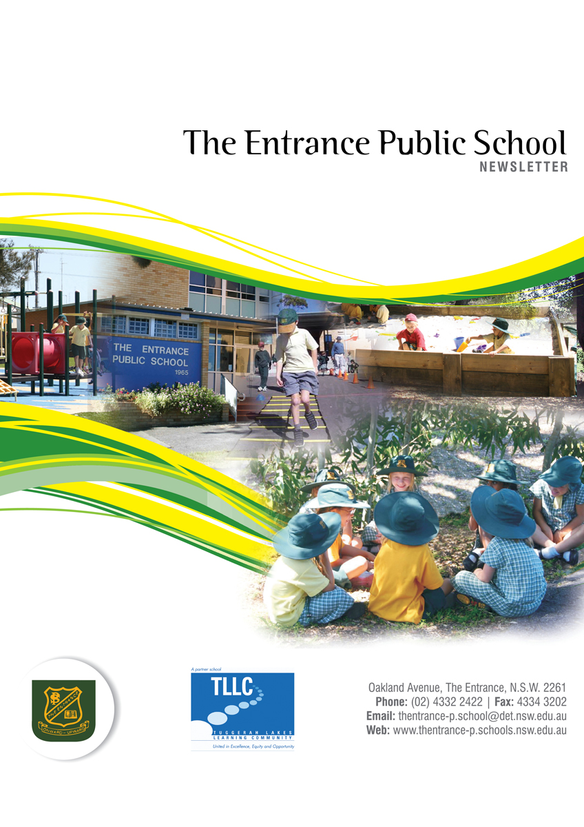
DATES TO REMEMBER
Mon 17 Oct - Fri 28 Oct - K-6Swim Scheme
Wed 19 - Wed 9 Nov - Kindergarten Orientation Headstart Program
Thur 20 Ball Games Gala Day
Fri 21 K-6 Assembly 9:30am
Tues 25 Stage 1 Seasons for Growth
Circle of Security Parent Program 9:15am – 12:30pm
Wed 26 Year 5 voting for School Captain Candidates 10am
T20 Stage 2 Milo Cricket boys & girls to Jubilee Oval
Fri 28 Bandana Day
Mon 31 Kuriwa AECG AGM 5pm
Tues 1 Nov Stage 1 Seasons for Growth
Circle of Security Parent Program 9:15am – 12:30pm
Thurs 3 Stage 2 League Tag
Fri 4 K-6 Assembly 9:30am

Wed 16 Nov Tumbi High School Orientation Day for Year 6 Students
Fri 18 Year 6 Fete 11:15am – 1:15pm

Mon 12 Dec Years 3-6 Presentation Assembly 9:45am
Tues 13 K-2 Presentation Assembly 9:45am
Channel Preschool Presentation 2pm
Wed 14 Year 6 Farewell – Shelly Beach Surf Club
Thurs 15 Lake Preschool Presentation 10am

PRINCIPAL’S REPORT
Welcome to Term 4, and already the students have settled back into their class routines and as I visit classes the amazing work that is happening every day is pleasing. This term is 10 weeks and we are already in Week 2.

Congratulations to those students who are reading every night, we have started handing out our 250 night reading certificates. Keep up the great work.

Good luck to all our swim school participants over the next two weeks, the skills that will be developed will mean this summer our students will be safer in and around water. I also look forward to a big participant rate at next years’ swimming carnival.

Our “Headstart” program for the 2017 kindergarten students is in full swing and it is amazing how confident and prepared the students are in their last year before Big School. It is not too late to join the “Headstart”, if you know of any families in our area that have children that are old enough to start school next year, ask them to contact our office.

A reminder that the toilets at school are for The Entrance Public School students use only, visitors to the school throughout the day including before school in the morning and afternoon pick up that need to use the toilets need to see the office and be directed to a staff or visitor toilet. Thank you for your assistance with this issue as it is for the safety of our students and is a child protection issue.

Kids, social media and privacy: Regardless of your child’s age, the world may already know a lot more about them than you suspect. According to recent research:
- 92% of children under the age of 2 have a digital shadow (- it starts with proud parents posting newborn baby photos on Facebook or Instagram)
- a quarter of Australian children 8 - 12 years old use
Facebook, but the minimum age for a user is 13 years.
- more than 20 per cent of tweens publish photos of themselves on Instagram
- young people 14 - 19 have an average of 453 fans, friends or followers on social media.

Have a great week!

Mark Rudd
PRINCIPAL
ADMINISTRATION NEWS
DID YOU KNOW?

VIA our school APP you can:
- Report your child’s absence
- Update contact details eg mobile phone, address, emergency contacts
- There is a link to our school newsletter
- See calendar of events
- Request a meeting with your child’s teacher

VIA our school website
(www.thentrance-p.schools.nsw.edu.au) you can:
- Make an online payment – look for the $ sign Make Payments. Brochure with information regarding Parent online Payments is attached.
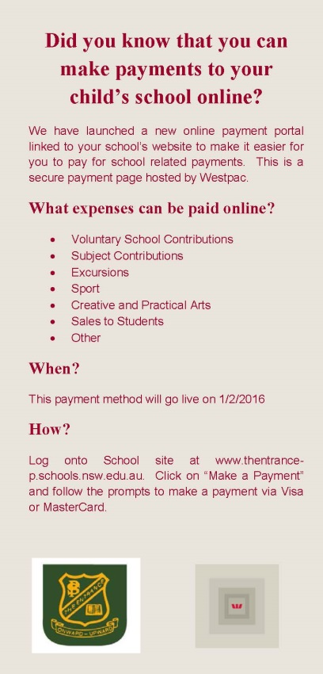

Please contact the office if you require assistance.

Property Central Attendance Award
Congratulations to Brad from 2/3M for receiving an attendance award for his 100% attendance during Term 3.

Property Central will continue to recognise attendance this term.
Cathy Burnside
Property Central
Preschool Enrolments for 2017
If you have a child who will be turning four years old before the 31st July, 2017 and you would like to enroll them in our preschool for next year, please collect an application form from the front office. There are only 40 places available. The preschool currently operates two groups; one operating every Monday and Tuesday and alternate Wednesdays, the other operating Thursdays and Fridays and the alternate Wednesdays.

Priority must go to children who live in The Entrance Public School area and will be attending kindergarten at The Entrance Public School in 2018. Preference must also be given to students who have a disability, come from a low socio-economic family situation and/or are of Aboriginal or Torres Strait Islander descent. A birth certificate is also required for proof of age.

The Garawa Pre-school is run by the Department of Education and fees have been heavily subsidised to cater for the needs of our community. This year the full fee rate per day is $15 per day. If the family has a Health Care card or are Aboriginal, fee relief is applied and the cost is reduced to $7.00 per day. To date fees have not been given to us for 2017.

DEPUTY PRINCIPAL’S REPORT
Welcome back, I hope everyone had a relaxing holiday and I am sure that the students are all refreshed and ready for a very busy term.

School Assemblies
Our K-6 assemblies this term will be held on Friday 21st October, 4th November and 2nd December, commencing at 9.30am. All parents are very welcome to attend these assemblies.

Our Annual Presentation Day Assemblies will be held on Monday 12th December for Years 3-6 and Tuesday 13th December for Kindergarten to Year 2. These assemblies will commence at 9.45am.

University of NSW Mathematics Exam
Congratulations to Jarwin 6S who received a Participation Certificate in the Mathematics Exam and special congratulations to Maddy 6S who received a Credit Certificate. Well done.

Kuriwa AECG
The next meeting of the Kuriwa Aboriginal Education Consultative Group (AECG) will be held on Monday 31th October, commencing at 5pm (venue to be confirmed). This will be the Annual General Meeting. All interested persons welcome to attend.

Win Bin Winners
The following students were drawn out for the win bin awards: Aiesha 1A, Victoria 2W, Lizzie 2W, Alexis 4L. Congratulations to all of our wonderful students.

Selective High School Placement for 2018
Information about Selective High School placement for students entering Year 7 in 2018 has arrived at the school. An information letter has been sent home to parents of Year 5 students. Applications must be completed online by Monday 14th November. Detailed instructions on how to apply online will be available at www.schools.nsw.edu.au/shsplacement

Selective High School placement provides intellectual stimulation and an educationally enriched environment for academically gifted and talented children in Years 7 to 12. Offers for Selective High School placement will be made on the basis of the Selective High School Placement Test, school assessment and other evidence of academic merit.

Gosford High School is the local fully selective high school. Gorokan High School is partially selective. If you have any questions, please feel free to contact Warren Mee or speak to your child’s class teacher.

Warren Mee
DEPUTY PRINCIPAL
Fighting Legend

We have a little Muai Thai fighting champion amongst us.

Nadar Collison of 3KD has been training 6 days a week to be the best at his weight division in Muai Thai fighting.

Previously, Nadar has competed in the Siam cup which was held earlier this year and saw him achieve a spot on the National team.

In November, Nadar will be travelling to QLD to fight in the Siam Cup eruption. This event is a really big show that takes place annually and sees the best of the best demonstrating their skills.

Nadar’s next competitive fight will see him challenging the current weight division champion for the title belt. If he is successful he will be given the opportunity to represent Australia in Thailand to be the BEST for his weight.

We will keep you posted on Nadar’s progress so watch this space.

K-6 BW NEWS
Term 4 already! It is difficult to believe that we are fast heading towards the end of another school year. We have another busy term planned at TEPS and a calendar of events was sent home with your child last week
K-6BW

As the weather warms up please remember to send in a water bottle with your child, clearly labelled with his/her name. If you prefer we can keep the bottle at school and refill it daily with tap water, just let us know if this is your preference.

At the end of Week 2, Mrs White will be commencing her maternity leave. We wish her all the very best and look forward to hearing exciting news from her in the coming weeks.

Home Reading Awards
Congratulations to the following hard working students who have recently received Home Reading Awards:

Ryan – 200 nights (Double Ocean)
Alana– 150 nights (Double Sand)

Mary Best, Gemma White & Sabien Stragliotto
Support Class Team

KINDERGARTEN NEWS
Hi everyone and welcome back to Term 4.

As the weather is starting to get hotter it’s important to remind everyone to bring hats and a water bottle to school with them every day. Please label everything with your child’s name and class so they can be returned to the right owner if lost.

SPORT will be on Wednesday for the following weeks: 19th October, 26th October and 2nd November.

SWIM SCHOOL started on Monday and it goes for 2 weeks, finishing 28th October. Students leave school at 12:30pm and get back at 3pm. They need to wear their swimmers under their uniform each day and take their towel, goggles (optional) and underwear in a plastic bag.

Congratulations to the following students who have received their Home Reading Awards:

Kinder Ainslie-
75 nights: Dane
100 nights: Ziggie
125 nights: Jacob
200 nights: Scarlett, Blair, Sarina

Kinder Quye-
75 nights: Tianshu
100 nights: Ayla
125 nights: Ayla, Grace
150 nights: Ayla

Kinder McFarlane-
50 nights: Aston
125 nights: Cooper
175 nights: Mia H
225 nights: Kaiden, Ruby
250 nights: Ruby

Kinder Andrews-
50 nights: Shayden
125 nights: Ruby
150 nights: Kiana
250 nights: Jamie

A big thumbs up to everyone who received a RESPECT, RESPONSIBILITY or PERSONAL BEST award at our mini assembly. Keep up the great work.

Stephanie Ainslie, Nicole Quye, Mardi McFarlane and Donna Andrews

STAGE 1 NEWS
Welcome back to the last term of the year. We hope everyone had a wonderful Spring holiday. Term 4 is always a productive, busy term, so please check bags for any notes and newsletters.

Swim school has started and will finish up Friday 28th October. Well done to all our Stage 1 students who have been learning the valuable and lifelong skill of swimming.

Due to other school commitments, Stage 1 Seasons for Growth will recommence on Monday 31st October (Week 4).

As we hadn’t yet had our Stage assembly, we only have our clever home readers listed this fortnight:

2C:
200 nights: Zoe
225 nights: Eliza and Chloe

2K:
125 nights: Jordan
175 nights: Brodie
200 nights: Nyaka
225 nights: Isla

2W:
125 nights: Bella-Rose
175 nights: Tomas
200 nights: Lisa
225 nights: Tesharnah

1A:
50 nights: Astin
100 nights: Talia
125 nights: Stephanie
225 nights: Cameron
250 nights: Jaxson

1B:
225 nights: Czhaay

1P:
25 nights: Kalea
50 nights: Halainah
K/1A:
125 nights: Miah

Year 1 Parents
Last week, Year 1 students brought home a Family ACTIVation Pack (one per family) – an awesome pack to get children and parents skilled, active & healthy!

The Family ACTIVation Pack is designed to help parents / carers get active with their children by playing quick, easy and fun games at home, in the park or wherever games that reinforce the fundamental movement skills already being learnt at school. There are all sorts of tips, ideas and guides for getting active including putting together an ‘Active Home Entertainment Centre’.

This resource has been developed by Central Coast Local Health District and supported by the NSW Department of Education. 4000 Family ACTIVation Packs are being distributed to primary schools on the Central Coast during this Term.

For more details check out the website www.healthpromotion.com.au click on Q4:Family Activation Pack.

We hope this pack helps families to get skilled, get active and get healthy!

Regards
Stage 1 Team
STAGE 2 NEWS
Dear Parents/Caregivers,

Welcome back to Term 4. I hope that you all enjoyed the two week break and were able to relax and recharge ready to work hard this term. It looks like it will be a busy and fun filled term ahead.

We have swim scheme taking place in Week 2 and 3 as well as many other sporting opportunities for our students.

Please remember that if you would like to speak to your child’s teacher about an issue, please arrange a time so that you don’t feel like we are ignoring or dismissing your concerns.

Stay tuned to our Newsletters for Term 4 Weeks 4, 6, 8 and 10, they will keep you updated on all the exciting events planned.

Here at The Entrance Public School, we encourage students to take responsibility for all the actions that they make in the classroom, playground and at home. When students start taking responsibility for their actions, they demonstrate awareness of the choices that they can make and generally as a result, make the right choice.

Being responsible means:
- Following the teacher’s instructions
- Listening to others
- Being in charge of your actions
- Encouraging others to follow rules
- Telling the truth
- Admitting to and fixing your mistakes
- Taking care of your belongings
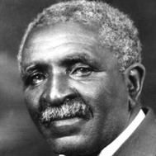
Education is the key to unlock the golden door of freedom.

George Washington Carver

Swim Scheme
Stage 2 students who are attending Swim Scheme will leave on the bus for the pool at 11:30am and return by 2pm. If your child is attending Swim Scheme, make sure they have their towel, swimmers and a dry set of school uniform to put on. Students are able to wear thongs/sandals AT THE POOL ONLY. They must have shoes on before they leave for and when they return back to school.

Please ensure that all their clothing is labelled with their name so that all items can be returned if lost.

Stage 2 Rewards Day
Unfortunately due to extremely windy weather at the end of Term 3, we were unable to visit the beach for our Rewards Day. Students who were eligible for the Rewards Day still enjoyed a movie with some delicious popcorn as an alternative. We will have our beach Rewards Day at the end of this term for those students who have achieved their Onwards and Upwards.

Attendance Chatter
The start of a new term is always an exciting time! Even though this is the final term of the school year, teachers will be continuing to teach quality and important lessons that will definitely benefit your child and their learning. It is vital that students continue to attend school regularly to ensure that they are making the most of their learning opportunities. We will continue to monitor attendance of all our students on a daily basis this term. A focus for the next two weeks will be on arriving at school on time before the 9:15am and being picked up at 3:15pm.

What’s Happening in 4L!
4L had an awesome end to Term 3 with our Stage 2 excursion to Mangrove Mountain. The students embraced the new challenges and worked hard to conquer their fears. 4L participated in rock climbing and fencing and had a blast. We were also lucky enough to have front row seats to watch Mr Nguyen tackle the giant swing – a highlight of the day.

This term we are reading The Twits by Roald Dahl and we are already having a good laugh at some of the pranks the couple of ‘twits’ play on each other. The story has a great underlying message about the importance of being nice to each – a focus for 4L this term.

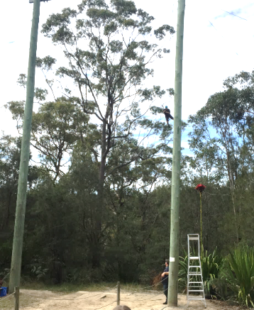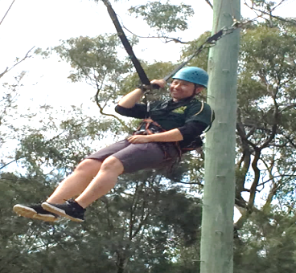

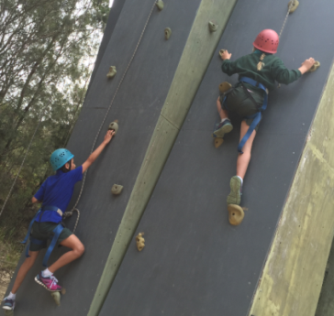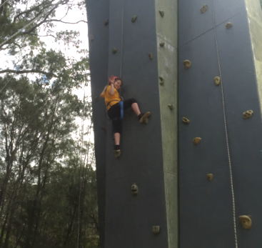

Regards
Stage 2 Teachers

STAGE 3 NEWS

Hey Team,

Welcome back to what is going to be a very hectic Term for Stage 3.

Canberra

Stage 3 had a great time visiting Canberra on the final three days of Term Three.

Students had the opportunity to visit; The High Court of Australia, Telstra Tower, The National Museum of Australia, The Embassies, Parliament House, The Dinosaur Museum, Questacon and the National War Memorial. In addition to the work done in classrooms our student had the opportunity to participate in a variety of educational programs that had a focus on Australia’s history, culture, heritage and democracy.

The Australian government recognises the importance of all young Australians being able to visit the national capital as part of their Civics and Citizenship education. To assist families in meeting the cost of this excursion, the Australian Government is contributing funding of $20 per student under the Parliament and Civics Education Rebate Program towards those costs (this was included in the pricing of your child’s excursion and assisted us in making this excursion affordable for students). The rebate is paid directly to our school upon completion of our excursion.

Transition to Tumbi

This term is a busy term for Year 6 students as they ‘gain pace’ in their transition towards high school. On Tuesday between Weeks 2 and 6 of this term teachers from the high school will be visiting our school in order to support students in the transition towards high school. This is a really important program and goes a long way to ensuring that every student moves towards high school equipped and ready to go.

High School Orientation Day

Year 6 students have a high school orientation for TLSC- Tumbi Umbi Campus on Wednesday 16th November. On this day students will travel to and from high school using the mode of transport they will typically use next year. On this day they will meet teachers from the high school, students from other partner primary schools who will form Year 7 in 2017. More information will be given out regarding this day closer to the event.

High School Gala Day

Following on from the Orientation Day Year 6 students will also attend a transition Gala Day on Wednesday 7th December. On this day students will participate in various sports alongside the students that will form Year 7 2017 at Tumbi High School. Likewise more information will be given out closer to this event.

Year 6 Fete

Last week students began preparing for our Year 6 Fete. The Year 6 Fete will be held during school time on Friday 18th November. This is an opportunity for Year 6 students to raise money for their Year 6 Farewell and for a gift that they will present to the school at the Farewell. This fete is for students only and is not open to parent, caregivers or members of the community.

Year 6 Farewell

The Year 6 Farewell will be held on Wednesday 14th December at Shelley Beach Surf Life Saving Club. Look out for information regarding a meeting for interested parents and caregivers about this event.

Have a great week.

Russell Stefans
Assistant Principal- Stage 3

RUSSELL.STEFANS@det.nsw.edu.au
The LaST News (Learning and Support Teachers)
Home Reading
Congratulations to the following students for their wonderful efforts in our Home Reading Program. Books have been awarded to Jakub, Tomas, Kiana, Laykin, Alana and Maddalin for reading for 150 nights and to Chloe, Callum, Nyaka, Scarlett, Lisa, Blair, Ruby, Ryan and Sarina for their 200 nights of reading. A huge congratulations must go to Ruby for achieving 250 nights. Our lucky book prize winners were Eliza, Talia and Cameron.

There are still lots of fantastic books to choose from so keep up the great efforts.

Tell Them From Me Surveys

Parents are invited to participate in the Tell Them From Me surveys. The survey is completed on-line and is run by an independent research company, The Learning Bar, which specialises in school-based surveys. This survey will help the school better understand how to improve student wellbeing and engagement. It will help the school identify what works to improve student outcomes. We encourage all parents to access this survey at https://nsw.tellthemfromme.com/7vvhh All answers are anonymous.

Alternatively a parent session will be offered in our top computer room this Thursday 20th October straight after morning assembly for you to complete the survey. Survey closes Friday 21st October.

Seasons For Growth

The Stage 3 students have completed the program and will be celebrating their achievements in the coming weeks. The stage 3 boys’ celebration will be held on Thursday 27th October at 2:15pm in Oasis. The stage 3 girls’ celebration will be held on Thursday 3rd November at 2:15pm in Oasis.

Due to swim scheme and other timetabling clashes this term, the stage 1 students will recommence Seasons For Growth on Monday 31st October.

Sue Densmore & Jodie Harris
Learning and Support Teacher

CANTEEN NEWS
Hi Everyone,

New Canteen Menu is out now. We no longer have lasagna or macaroni cheese as our summer menu is out now.
Bandana Day is on
28 October

We are now selling Bandana’s through the canteen only for $4.00 each to help support kids with Cancer

Volunteers needed – canteen helpers required. We would love new volunteers if you can help out for 1 day a week, fortnight, monthly, or a couple of hours here and there. We would love to have you come in, a great way to meet new Mums, and your kids will love it. See either Emma or Kerry.

CANTEEN ROSTER
Thurs 19th Oct Razaan, Kristie HELP NEEDED
Fri 20th Sandi, Kylie. Shay
Mon 23rd Rita, Brooke, Kristie
Tues 24th Sammi, Kaylah HELP NEEDED
Wed 25th Brooke, Kristie
Thurs 26th Kristie, Razaan HELP NEEDED
Fri 27th Kylie, Sandi, Shay
Mon 31st Brooke, Kristie, Rita
Tues 1st Nov Kaylah, Sammi HELP NEEDED
Wed 2nd Kristie, Brooke, Mel

Cheers,
Emma Brophy
4333 5174

